
Microsoft SQL Server Version 2000
Full-Text Search Deployment

Microsoft Product Support Services White Paper
Written by Purna Gathani, Sade Fashokun, Rashid Jean-Baptiste

Additional contributions by Andrew Cencini, John Kane, Steve Tullis

Published on May 30, 2002

Abstract
The full-text search component of Microsoft SQL Server 2000 provides a rich text retrieval system. This white paper is for database administrators who:
- Have to deploy full-text search applications.
- Have to use full-text search.
- Want to explore what full-text offers or just aspire to gain more knowledge about full-text search.
This white paper outlines the following:
- The hardware and operating system requirements for efficient full-text
search performance.
- Full-text search architecture.
- Full-text search administration.
- How to monitor full-text search performance.
While this white paper is written specifically for SQL Server 2000, most of the information is also useful for Microsoft SQL Server 7.0 database administrators.
Note Some material in this white paper has been adapted from Microsoft SQL Server Books Online.

The information contained in this document represents the current view of Microsoft Corporation on the issues discussed as of the date of publication. Because Microsoft must respond to changing market conditions, it should not be interpreted to be a commitment on the part of Microsoft, and Microsoft cannot guarantee the accuracy of any information presented after the date of publication.
This White Paper is for informational purposes only. MICROSOFT MAKES NO WARRANTIES, EXPRESS OR IMPLIED, AS TO THE INFORMATION IN THIS DOCUMENT.
Complying with all applicable copyright laws is the responsibility of the user. Without limiting the rights under copyright, no part of this document may be reproduced, stored in or introduced into a retrieval system, or transmitted in any form or by any means (electronic, mechanical, photocopying, recording, or otherwise), or for any purpose, without the express written permission of Microsoft Corporation.
Microsoft may have patents, patent applications, trademarks, copyrights, or other intellectual property rights covering subject matter in this document. Except as expressly provided in any written license agreement from Microsoft, the furnishing of this document does not give you any license to these patents, trademarks, copyrights, or other intellectual property.

© 2000 Microsoft Corporation. All rights reserved.
Microsoft, SQL Server, Windows 98, Windows 2000, Windows Millennium, Windows NT, and Visual Basic are either registered trademarks or trademarks of Microsoft Corporation in the United States and/or other countries.
The names of actual companies and products mentioned herein may be the trademarks of their respective owners.

Contents
Introduction 1
Why use Full-Text Search? 3
Full-text Search Capacity Planning 4
Hardware Considerations 5
Microsoft Windows 2000 or Microsoft Windows NT 4.0 System Configuration Considerations 5
Memory Configuration for Microsoft Search and Microsoft SQL Server 6
Full-Text Catalog Considerations 6
Installation of Full-Text Search 8
Full-Text Search Checklist 9
FULL-TEXT Search Architecture 10
Indexing Component 10
Query Component 15
Other Full-Text Search Concepts 18
Population Considerations 18
Full-Text Index and Catalog Placement Considerations 19
Localization 19
Image Filtering 22
Full-text Search Administration 24
How to Enable a Table for Full-Text Indexing 24
How to Populate a Full-Text Index 34
How to Drop or Rebuild a Full-Text Catalog 39
Full-Text Search Query Predicates 40
CONTAINS 40
FREETEXT 40
CONTAINSTABLE 41
FREETEXTTABLE 41
Top_n_by_Rank 42
Monitoring Full-text Search 43
System Monitor Counters 43
Full-Text Indexing or Population-Related Counters 43
Full-Text Search Query-Related Counters 45
Basic Full-Text Indexing Troubleshooting 49
How to Recover from a catastrophic Failure 50
For More Information 51

Introduction
Microsoft® SQL Server™ 2000 provides a rich text retrieval system. It uses the Microsoft Search service as a full-text indexing and search engine. In SQL Server 2000, the Microsoft Search service has two primary roles:
- Indexing Support: Defines, creates, and populates full-text indexes and catalogs for the database.
- Querying Support: Processes full-text search queries. The types of queries supported include searches for:
- Words or phrases.
- Words in close proximity to each other.
- Inflectional forms of verbs and nouns.
Additionally, with the enhanced Microsoft Search Engine in SQL Server 2000 you can:
- Update indexes in the background.
To make sure that the full-text index is always up-to-date, the population of a full-text index can run in the background without interfering with other tasks on the server. There are several different ways to update an index in the background and they are discussed in detail in the "FULL-TEXT SEARCH ARCHITECTURE" section of this white paper. This feature was introduced in SQL Server 2000.
- Maintain a full-text index.
Depending on your data and resources, you can choose from the following three methods to maintain a full-text index:
- A full rebuild.
- A timestamp-based incremental rebuild.
- A change tracking method.
For more information, read the "FULL-TEXT SEARCH ARCHITECTURE" section of this white paper.
- Index and search data that is stored in image columns.
You can use full-text search to index and query certain types of data that are stored in image columns. Full-text search uses one of several supported filters to extract and interpret the text data for indexing and querying. SQL Server provides filters for the .doc, .xls, .ppt, .txt, and .htm file name extensions. Additionally, any filter that is registered for the indexing service (or another Microsoft Search application) is also available to the SQL Server full-text search. For more information, read the "Image Filtering" section of this white paper. This feature was introduced in SQL Server 2000.

- Limit the number of matches returned.
Use of the Top_n_by_Rank parameter, with a full-text predicate, returns
only the top n highest ranked matches, in descending order. For more information, read the "FULL-TEXT SEARCH QUERY PREDICATES" section of this white paper.

Why use Full-Text Search?
With a full-text query, you can perform a linguistic search of character data. A linguistic search can operate on words and phrases unlike a LIKE predicate, which only works on character patterns. Additionally, a full-text query can weigh how well the results that are returned rank in comparison to the original search condition. This is not possible with a LIKE predicate, because it only returns the results that contain the query term.
Other differences between character based searches performed by a LIKE predicate and linguistic searches performed by full-text are:
- A full-text search can remove noise words from the search criteria, hence making the search more effective. This is not possible with a LIKE predicate.
- A full-text search permits language specific search. This is not possible with a LIKE predicate.
- With a full-text search, the data is up-to-date up to the last population unless Change Tracking is turned on with the Update Index in Background option turned on. With the LIKE predicate, the data that the full-text search returns is always up-to-date. Read the "FULL-TEXT SEARCH ARCHITECTURE" section of this white paper for an explanation of the Change Tracking and Update Index in Background options.
- A full-text search is more efficient at searching large tables (greater than 1 million rows) because it uses a pre-composed index. In comparison, a LIKE predicate must search for the string through the whole table at query time.

Full-text Search Capacity Planning

The key to a successful implementation of full-text search requires:
- Careful planning of hardware.
- An understanding of the environment in which you will deploy the full-text search.
- An understanding of the scalability needs of the tables that will be involved in the full-text search.
As a guideline, consider answering the following questions:
- How many tables are going to participate in the full-text search?
- What are the size of the tables (in MB or GB) and the number of rows on which you will create a full-text index?
- What is the potential growth of the tables on which a full-text index will be created.
- What is the language of the columns on which a full-text index will be created?
- How soon do users have to query newly created or modified data in the full-text indexes?
- How many users will be concurrently running full-text search queries?
- Other than SQL Server, are there going to be any other applications running on the server?
- What kind of hardware does the server have (number of CPUs, memory, disk subsytem)?
Understanding and answering these questions is the first of several steps you must follow to plan and implement full-text search. The following excerpt is from SQL Server 2000 Books Online:
If you are full-text indexing tables that have less than a million rows, very little performance tuning is required. If you full-text index large SQL Server table(s) that contain millions of rows (at present or has a potential in future) that create large full-text catalogs, this will sustain heavy read and write activity, so you must configure SQL Server and the full-text catalogs to maximize disk I/O performance by load balancing across multiple hard disk drives. You will also need to consider hardware configurations, Microsoft Windows® 2000 or Windows NT® 4.0 system configurations, and SQL Server 2000 configurations, as well the actual location of the full-text catalogs and database files.
A discussion about the specifics of each of these configurations follows.

Hardware Considerations
- Multiple CPUs: One to four 500-megahertz (MHz) Xeon III processors.
- Memory: 1 to 4 GB of physical RAM.
- Multiple disk controllers with several channels or a single disk controller with multiple channels.
- Disk I/O sub-systems: RAID 0 (disk striping with no fault-tolerance protection), RAID0+1 and RAID5.

Microsoft Windows 2000 or Microsoft Windows NT 4.0 System Configuration Considerations
SQL Server 2000 is fully supported on both Windows 2000 and Windows NT. However, on Windows 2000, the Microsoft Search service takes advantage of new features that improve full-text index performance. Specifically, the Microsoft Search service has the following enhancements:
- Multi-threaded word breaking.
- Reduced disk footprint.
- Better merge strategy.
- Better query path processing.
Here are some other considerations:
- If you install and plan to use the full-text search feature, then set the Microsoft Windows NT Server or Microsoft Windows 2000 configuration to maximize throughput for network applications. You must not change this setting.
To access this setting on a computer that is running Microsoft Windows NT, follow these steps:
  - Open Control Panel, and then double-click Network.
  - On the Services tab, click the Server service, and then click Properties.
To access this setting on a computer that is running Microsoft Windows 2000, follow these steps:
- Click Start, point to Settings, and then click Control Panel.
- Double-click Network and Dial-Up Connections.
- Right-click Local Area Connection, and then click Properties.
- Click File and Print Sharing for Microsoft Networks, and then click Properties.
- For a Microsoft Windows 2000 Server, Microsoft recommends that you select the Optimize performance for background services option. To access this setting, follow these steps:
- Open Control Panel, and then double-click System.
- In the System Properties dialog box, click Advanced.
- On the Advanced tab, under Performance, click Settings.
- In the Performance Options dialog box, click Advanced.
- If SQL Server 2000 is installed on Microsoft Windows NT Server 4.0, the Pagefile.sys file must be sized one and a half to two times the amount of available physical RAM. To avoid this consideration, install SQL Server on Microsoft Windows 2000 Server with larger amounts of RAM. This is because the Microsoft Search service in Windows 2000 takes better advantage of the Microsoft Windows NT file system (NTFS file system) cache.
- Place the Pagefile.sys files on their own drives (RAID 0 or RAID 0+1), preferably on a separate controller or least a separate channel off a shared controller.

Memory Configuration for Microsoft Search and Microsoft SQL Server
The default memory setting for SQL Server is dynamic. SQL Server 2000 can use all the available memory on the server and leave the minimum required for the operating system. Microsoft generally recommends that you not change the default settings. However, there are some exceptions where it is best to make a change in the configuration options. Full–text is one such exception. To leave enough memory for full-text search (Microsoft Search service) and other applications on the server to run, you must manually set the SQL Server 2000 max server memory configuration option. Microsoft recommends that you reserve a minimum of 15 MB and a maximum of 512 MB of memory for the Microsoft Search service, depending on the number of rows in the full-text indexed tables.

Full-Text Catalog Considerations
When making the decision about the placement of full indexes and catalogs, here are some things to consider:
- Place full-text catalogs on their own disk controller or off of a separate
channel on a single disk controller with multiple channels.
- Place the database files on a separate disk controller from the

full-text catalog files or off of a separate channel on a single disk controller with multiple channels.
- The Microsoft Search service requires the hard disk (preferably RAID 0+1)
that contains the full-text catalogs to have enough free disk space at all times; otherwise, the population may fail. The size of the full-text catalogs ranges from 30-40 percent of the maximum data size of the full-text enabled columns. Therefore, you must make sure that there is enough disk space for the full-text catalogs, and for potential growth.
- By default, the Microsoft Search service creates and uses the temporary
files that are installed on the system disk (%systemroot%\Temp\Gthrsvc) when a full-text index is created on an image column. Depending on the type of file (.doc, .htm, and so forth), and the size of the file that is stored in the image column, the temporary files may experience heavy usage, which then leads to high I/O activity. Because the system disk does not have the I/O throughput of a RAID array, you must move the temporary folder to a RAID 0 disk array separate from the full-text catalogs.
Note To move the temporary folder, use the Settmppath.vbs utility. By default, Settmppath.vbs is located in the Program Files\Common Files\System\Mssearch\Bin folder. However, if you have installed SQL Server 2000 on a computer that is running Microsoft Office XP, Microsoft SharePoint Portal Server or Microsoft Exchange 2000 Server Service Pack 1, Settemppath.vbs is stored in the Program Files\Common Files\Microsoft Shared\MSSearch\Bin folder. On a computer that is running Microsoft Windows 2000 Server with Windows Clustering, the temporary folder must be on a local disk on each node. Additionally, you must never set the path to the temporary files to the same location as the page files of the server (Pagefile.sys).
The following example uses the default location for the Settemppath.vbs script and moves the temporary files to %new location%:
cscript "c:\Program Files\Common Files\System\Mssearch\Bin\settemppath.vbs" %new location%

Installation of Full-Text Search
By default, full-text search (Microsoft Search service) is installed when a Typical or Minimum installation of SQL Server 2000 Standard, Enterprise, or Developer Edition is performed. During setup, SQL Server adds itself as an administrator of the Microsoft Search service.
In Microsoft SQL Server 7.0, you must perform a custom installation to install full-text search or you can add it after the installation as an Add-on component.
If you upgrade from SQL Server 7.0 to SQL Server 2000, only the components that were installed for SQL Server 7.0 are upgraded. If full-text search is not installed on SQL Server 7.0, the upgrade to SQL Server 2000 does not include full-text search. You must add it separately after the upgrade completes.
You have to consider the following limitations about the Microsoft Search service:
- The Microsoft Search service is not available on:
- Microsoft Windows NT Workstation
- Microsoft Windows 2000 Professional
- Microsoft Windows Millennium Edition
- Microsoft Windows 98
SQL Server databases that run on these platforms do not support full-text catalogs and indexes. However, applications that run on these operating systems can use full-text capabilities if they connect to an instance of SQL Server 2000 or SQL Server 7.0 on a different computer that supports them.
- There is only one Microsoft Search service on any computer that runs multiple instances of SQL Server. A single instance of the full-text search engine manages the full-text indexes for all the instances of SQL Server 2000 and SQL Server 7.0 on the computer.

Full-Text Search Checklist
To make sure that the full-text search works properly, the following security credentials must be maintained:
- The SQL Server 2000 Setup program installs the Microsoft Search service (MSSearch.exe) and Microsoft Search service runs under the LocalSystem account.
Note Changes to the Microsoft Search service startup account are not supported.
- Verify that the account used by SQL Server has the following permissions:
- Log On Locally
- Log On as a Batch
- Access this computer from the Network
- Log on as service
- Replace a process level token
- Act as part of the operating system
- Increase quotas
Because SQL Server Enterprise Manager maintains the security relationship between SQL Server and the Microsoft Search service, you must only use SQL Server Enterprise Manager to perform changes to the SQL Server startup account. If, for some unknown or unforeseen reason, you perform changes to the startup account used by SQL Server by using the following sequences
On Windows NT, point to Start, point to Settings, and then click Control Panel. Double-click Services, double-click MSSQLServer (or MSSQL$instancename), and then click Log On.
-or-
On Windows 2000, click Start, point to Programs, point to Admin Tools, and then click Computer Management. Click Services and Applications, and then click Services. Double- click MSSQLServer (or MSSQL$instancename), and then click Log On.
you must reapply the changes by using SQL Server Enterprise Manager.
- Verify whether you have the [NT Authority]\System added as a SQL Server login and that the login has system administrator rights.
- Verify whether you have the BUILTIN\Administrators login. If you do not have the BUILTIN\Administrators login, create one, set the master database as the default database, and then grant the BUILTIN\Administrators login system administrator rights. This step is optional.

FULL-TEXT Search Architecture
Microsoft SQL Server 2000 interacts with the Microsoft Search Engine to create, maintain, and query full-text indexes. Full-text indexes are stored in full-text catalogs. A full-text catalog is a separate set of files that the Microsoft Search service manages. Only the Microsoft Search service, and the Windows NT or Windows 2000 system administrator can access the full-text catalog files. Full-text indexes differ from regular SQL Server indexes in a number of ways:
- The full-text indexes are stored in the file system, but they are administered through the database.
- The full-text index must be populated. Population of a full-text index involves the retrieval of the text data from the SQL Server tables and the storage of that data in the full-text index.
- You cannot define a full-text index on a view, system table, or temporary table.
- Full-text indexes are grouped in a database into one or more full-text catalogs. A full-text catalog is a holder for full-text indexes. Each full-text catalog can serve the indexing needs of one or more tables in a single database, and each table in a database can have only one full-text index.
Now that you have a basic understanding of what you have to do to implement or deploy a full-text search and how it is installed, let us take a closer look at the architecture of full-text search.
There are two components involved in the SQL Server full-text search:
- Full-text indexing.
-and-
- Full-text querying.
The Microsoft Search service provides both of these capabilities. Now, let us discuss the architecture of each of these components.

Indexing Component
The indexing component of a full-text search is responsible for the initial population of the full-text index and the subsequent update of this index when the data in the full-text indexed tables is modified.
The following sub-components make up the architecture of the indexing component:
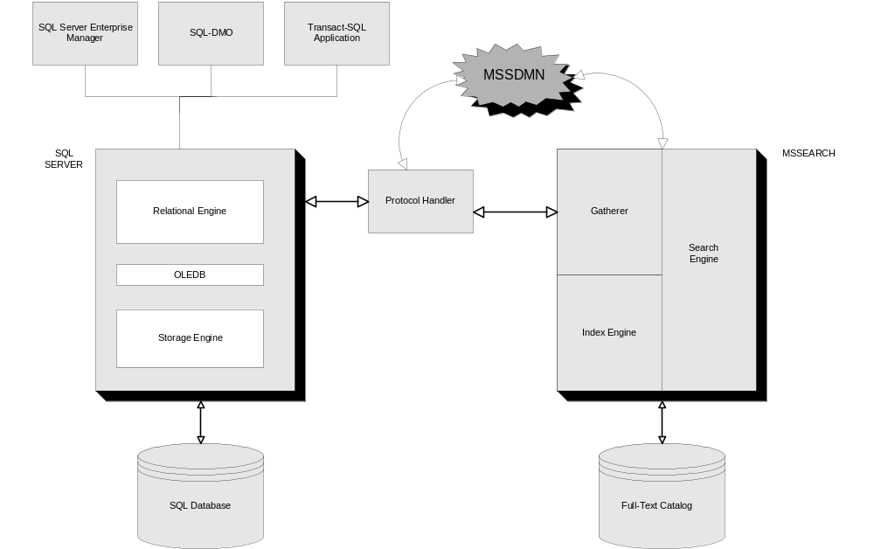
Figure 1 - Full-text Indexing Component
- Enterprise Manager GUI or admin stored procedures
You manage a full-text index by using SQL Server Enterprise Manager or the following Transact-SQL stored procedures:
- sp_fulltext_database
- sp_fulltext_catalog
- sp_fulltext_table
- sp_fulltext_column
- sp_fulltext_service
For more details about how to create, populate or maintain a full-text index, read the "FULL-TEXT SEARCH ADMINISTRATION" section of this white paper.
- Microsoft Search Gatherer is a plug-in to the Microsoft Search process. Microsoft Gatherer is responsible for the creation of an empty catalog,
and for setting up and populating the full-text indexes on a particular table.

- The Microsoft Search Service Filter Daemon (Mssdmn.exe) is the process that is started by Microsoft Gatherer. Mssdmn.exe is responsible for loading the protocol handler and for the population of a full-text index or catalog. If a problem occurs, only the Daemon process closes, while MSSearch continues to function and service other catalogs.
- The SQL Server Protocol Handler is a registered COM component that is loaded and used by the Filter Daemon process. The SQL Server Protocol Handler understands the SQL Server format and exposes the data to
MSSearch.
- MSSearch Indexer indexes the data and stores it in a catalog.
Here is an overview of how each of the components work together when a full-text index is created and populated.
- If the database is not enabled for full-text indexing, you must enable the
database.
- Create or specify a full-text catalog.
- Individual tables are enabled for full-text indexing and associated with a
catalog.
- Individual columns in each table are added to the full-text index for
the table. All the meta data information from steps from 1 through 4 is stored in system tables in SQL Server databases.
- The full-text indexes for each table are activated on a table-by-table
basis. When a full-text table index is activated, a start seed value is sent from an instance of SQL Server to the indexing service in the Microsoft Search service. The start seed value identifies the table that is involved in the full-text index.
- Population is requested on either a catalog-by-catalog or table-by-table
basis. Populating on a catalog basis permits you to populate multiple indexes in one operation; populating tables allows you to populate specific indexes.
The population in the last step can take different forms:
- Full Population
If a full population is requested for a full-text catalog, index entries are built for all the rows in all the tables that are covered by the catalog. If a full population is requested for a table, index entries are built for all the rows that are in that table. A full population typically occurs when a catalog or index is first populated. You can then maintain the indexes by using change tracking or incremental populations.
- Incremental Population
An incremental population updates entries for rows that were inserted, deleted, or updated since the last population. This feature requires the indexed table to have a timestamp data type column. You use the timestamp column to determine if any changes were made since the last population. If the table does not have a timestamp column, you can only perform full or change tracking populations.
Note Requests for incremental populations on tables without timestamp columns result in a full population operation.
- Change Tracking Population
Change tracking population stores the changes that are made to a full-text indexed table in a system table. SQL Server then propagates the changes to the full-text index.
Note Enabling a table for change tracking causes a full population of the full-text index. Therefore, be careful if you enable this option, especially on large tables (greater than or equal to 1 million rows).

There are three ways to propagate the changes to the full-text index when you use change tracking:
- Background
With this option, the changes are propagated to the full-text index as they occur.

- On demand
With this option, the changes are propagated to the full-text index, as the name implies, on demand through the update_index action specified with the sp_fulltext_column, or sp_fulltext_table stored procedures or through SQL Server Enterprise Manager.

- Schedule
With this option, you can use the SQL Agent to schedule jobs that run the same command that is run to start a change tracking population on demand.
Each population request is sent to the indexing engine in the Microsoft Search service:
- The indexing engine passes the appropriate start seed value to the
Mssearch Gatherer. The Gatherer starts the Microsoft Search Service Filter Daemon process, which in turn loads the SQL Server Protocol Handler. The start seed value contains information such as the table and index involved in the population, and the timestamp value (if the table has a timestamp column) associated with the last full or incremental population performed for the index.
- The SQL Server Protocol Handler makes a connection to SQL Server to
gather or retrieve a list of unique key values present in the table. After the SQL Server Protocol Handler establishes a connection, the SQL Server Protocol Handler issues a remote procedure call (RPC) request to SQL Server with a call to the sp_fulltext_getdata stored procedure. The SQL Server Protocol Handler translates each unique value into a "Unique Row URL" and then passes the "Unique Row URL" to the Gatherer.
- The Gatherer then requests data from all the columns that are marked for full-text indexing by making another call to the Protocol Handler. In the second pass, the sp_fulltext_getdata stored procedure obtains the data from the indexed columns in the table by using the "Unique Row URL." The SQL Server Protocol Handler collects the data, and then passes the data back to the Gatherer. The Gatherer updates the crawl seed value to the last unique row URL, and then forwards the data to the Index Engine, which manipulates it into an index format. The Gatherer logs any failure and writes error messages to the Application event log. This process of gathering is known as population.
The Index Engine rules noise words defined in the noise files such as:
- a
- and
- the
A predefined set of noise files are installed for all the supported languages. You can edit these noise files as required. The Index Engine takes the stream of data from the gatherer, determines the word boundaries, and breaks it into words by using a word breaker. The word breaker reduces the character stream to word stems (for example, running, runs, ran, run, ran, are all reduced to the same root word "run") before they are put into the index. This linguistic analysis differs depending on the language in which the text is written. SQL Server 2000 supports linguistic analysis for several languages. For more information, read the "Localization" section in this white paper. The process that performs the indexing is Mssdmn.exe (Microsoft PKM Search Filter Daemon). For more information about the indexing process, search for the "Indexing Service" topic on MSDN, or visit the following Microsoft Web site:
Architecture of Indexing Service
(http://msdn.microsoft.com/library/default.asp?url=/library/en-us/indexsrv/html/ixarch_5hyd.asp)
The full-text index is stored in the full-text catalog file.
Note When you are performing benchmarking, use the Performance Monitor process counter, and then use the Mssdm.exe object to time how long your indexing process takes. This step is very important when you are deciding which form of population you must run.
- At the end of the population, the indexing service calculates a new start seed value that records the point at which a subsequent incremental population must start.

Query Component
The query component accepts a full-text predicate from SQL Server, transforms the predicate into a command tree and sends the command tree to the Microsoft Search service.
The Microsoft Search service returns a matching rowset by using the full-text provider.
A full-text predicate from SQL Server includes one or more of the following Transact-SQL commands:
- CONTAINS
- FREETEXT
- CONTAINSTABLE
- FREETEXTTABLE
Let us look at the components involved during the querying process.
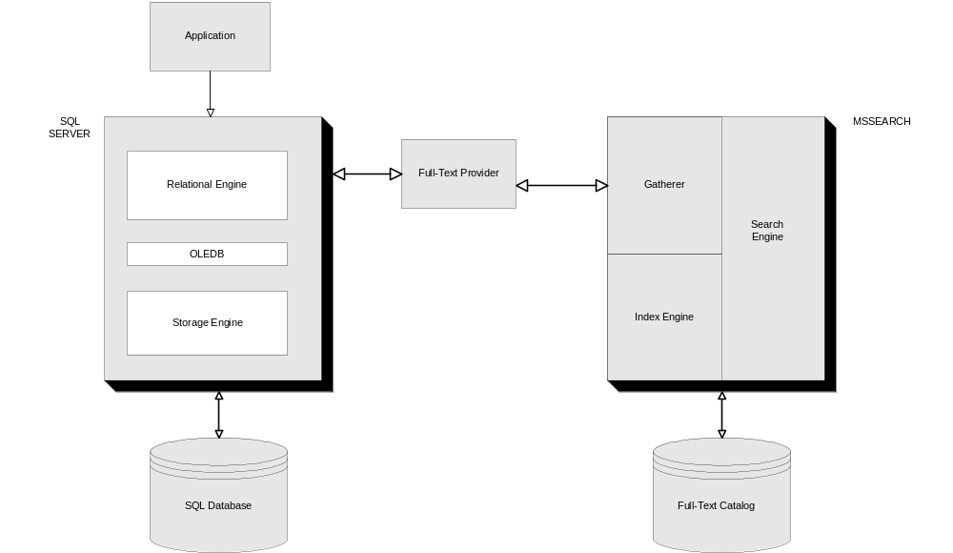
Figure 2 - Full-text Querying Component
From the "Full-text querying support" topic in SQL Server 2000 Books Online, the steps involved in this process include:
- An application sends an instance of SQL Server a Transact-SQL statement with a full-text construct.
- The SQL Server relational engine validates the full-text construct by querying the system tables to determine if the column reference is covered by a full-text index. The relational engine reduces each SQL statement to a series of rowset operations, and uses OLE DB to pass the operations to underlying components, generally the storage engine. The relational engine transforms any full-text construct into a request for a rowset from the full-text provider instead of the storage engine. The rowset requested is the set of keys satisfying the search condition and a ranking indicating how well the data for each key met the search condition criteria. The command sent with the rowset request to the full-text provider includes the full-text search condition.

- The full-text provider validates the request and changes the search conditions to a form used by the querying support component of the Microsoft Search service. The request is sent to the search service.
- The querying support component uses the search engine component to extract the requested data from the full-text index. This data is then passed back to the full-text provider in the form of a rowset.
- The full-text provider returns the whole result-set to the relational engine and then the WHERE clause is applied to the result-set.
- The relational engine combines all the rowsets it receives from the storage engine and the full-text provider to build the final result set and sends it back to the client.

Other Full-Text Search Concepts

Population Considerations
Here are some of the considerations that you must keep in mind when you choose one type of population versus another to maintain a full-text index:
- Use the change tracking option with the background update index option when CPU and memory is available, immediate propagation can keep up with the rate of changes and the value of an up-to-date index is high.
- Use change tracking with scheduled propagation when CPU and memory can be over-used at scheduled times, disk space is available to store the changes, and the changes between the scheduled times are not so significant that it may take longer than a full population.
- If any changes are made to the SQL Server data with either the
WRITETEXT or UPDATETEXT command, those changes are not reflected in the full-text index if you perform an incremental or change tracking population. Therefore, after any of these operations are performed on a full-text indexed table, you must initiate a full population.
- If there are any meta data changes made to a full-text indexed table,
the next population scheduled for that table must be a full population.
If you try to perform an incremental population, the Microsoft Search
service performs a full population. The meta data changes include the following:
- Modification of the definition of columns that belong to a
full-text index.
- Changes to the unique index that is used by a full-text index.
- Adding or deleting the columns involved in a full-text index.
- Whenever you modify noise word files, you must perform a full
population on all full-text catalogs. Noise word files are for the storage of noisewords. Noise words are words that do not help a search and only bloat a full-text index if they are stored. Some such words are:
- a
- and
- is
  - Whenever you change a word-breaker, generally when you upgrade
to a new operating system platform, you must perform a full population. Word-breakers are language specific components that are used to parse text documents to find word boundaries.

Full-Text Index and Catalog Placement Considerations
As stated in SQL Server 2000 Books Online, the placement of full-text indexes for tables in full-text catalogs play an important role in the resource usage and time it takes to maintain a full-text index after the initial full population. Whether each table receives a separate full text catalog or multiple tables are placed in the same catalog depend on several factors:
- If the table has or will have millions of rows, always place the full-text
index in its own catalog.
- Consider the update characteristics (such as a small number of changes
versus a large number of changes, or tables that change frequently during a particular time of day) of the tables that are involved in a full-text index. As a general rule, group the tables with the same characteristics in the same catalog.
- After a full-text index is created, there are several ways (Full Population, Incremental Population, or Background Update) to keep it synchronous with the table. For more details about the different methods of population, read the "FULL-TEXT ARCHITECTURE" section of this white paper. Remember, unlike a regular index that SQL Server updates when changes are made to the table, SQL Server updates a full-text index only when a population occurs. The population process is resource intensive and is performed at a catalog level. Therefore, SQL Server updates all the indexes that exist in the catalog at the same time.

Localization
It is possible to use full-text search in a single language or a mixed language environment. A mixed language environment is one in which different language characters are stored in the same column of a SQL Server table. Microsoft recommends that you use a supported language and that you not mix language characters in one column. However, if this is not possible, use the "neutral" language setting as the language for word breaker when you create a full-text index. Use the Neutral language for unsupported or mixed language environments. With the Neutral language setting, SQL Server performs word-breaking on the premise that words are delimited by white spaces in a character stream.
Also, in a mixed language environment, Microsoft recommends that you store the data in text or image columns (BLOBs) so that Microsoft Search can identify the textual language for indexing by the appropriate Locale ID (LCID) in the header of the document. When SQL Server creates a new document, most client applications will automatically put a default LCID in the header of the document. This default LCID is generally equal to the client's default locale.

You can specify the language for use with linguistic analysis on a column-by- column basis by using SQL Server Enterprise Manager or the sp_fulltext_column Transact-SQL command. For more details, read the "FULL-TEXT SEARCH ADMINISTRATION" section of this white paper. Alternatively, you can set the language for linguistic analysis server-wide by setting the default full-text language option of the sp_configure stored procedure to 0 for neutral or to the LCID for any of the supported languages. Valid values are documented in the "Full-Text Index and Querying Concepts" topic in SQL Server Books Online. Independent Service Vendors may also supply additional languages.
For example, a Microsoft Word document may contain both English and Japanese text, both of which are encoded (and in turn, interpreted by Microsoft Search) in the two respective languages during indexing. Queries on the columns contain multiple languages; however, the queries default to the column level language setting.
By default, for full-text processing, SQL Server supports the following languages for word-breaking, stemming, and noise-word control:
- Chinese (traditional and simplified)
- Dutch
- English (U.K. and U.S.)
- French
- German
- Italian
- Japanese
- Korean
- Spanish
- Swedish
- Thai
The server’s default locale handles languages that are not in the preceding list, that you have not installed, or that are not a sub-language that is a variation of these major languages. If the server’s default locale is unknown, then Microsoft Search service uses the neutral word-breaker.
To determine SQL Server’s default locale, run the following command from Query Analyzer:
Select @@language
The noise-word files for each language are stored in the MSSQL\FTData\SQLServer\Config folder. The names are in the form of Noise.*, where the asterisk (*) is a three letter representation of the language. You can use Notepad to edit these files.
You may also find a set of noise word files in the Program Files\Common Files\System\MSSearch\Data\Config folder (or some variant thereof). Changing the noise word files in this folder has no effect on the currently installed SQL Server instances. Instead, the files in this folder behave similar to the model database. Any future installations of applications that are registered with that instance of Microsoft Search will copy the noise word files in that folder to their own noise word location, and therefore inherit those changes.
The language used for indexing (including word-breaking, stemming, or noise-word control) can be different from the language that is used for querying.
Microsoft Search service determines the language for indexing in the following order:
- Use the language indicated by the document, if the column content
is a BLOB of image type and it contains LCID information.
- Use the language indicated by the column in SQL Server, if the
column is text.
- Use the default locale for SQL Server.
- Use the neutral word-breaker
The Microsoft Search service determines the language for querying in the following order:
- Use the default language of Microsoft Internet Explorer, only when
querying from a Microsoft Internet Explorer Web page.
- Use the default locale for SQL Server.
- Use the neutral word-breaker
If the data stored in a text column contains special formatting (such as HTML or XML tags), Microsoft recommends that you set the language of that column to neutral. Language resources other than those used for neutral may not always tokenize formatted text properly, whereas the neutral component is frequently better suited to tokenize formatted text. Switching to neutral language resources disables support for stemming in queries (through FORMSOF(INFLECTIONAL)) and text tokenization is generally performed on white space, punctuation, or symbols.
If the language you use to create a full-text index is different from the language used to query the same full-text index, then because of an overlap in languages, the results may seem somewhat odd. However, the results are predictable (if you know what is indexed and how you are querying, you can predict the results).
For example, if you search for the word "car" (in English) and all the indexed documents are in Spanish, they will contain the word "auto" and you do not get matches. Another example is the word "die." In English, die means "to cease
living"; however, in German "die" is the equivalent of the word "the" and is dismissed as a noise word.
The following scenarios demonstrate how various language settings affect the full-text indexing and query behavior.
Example A
If a Microsoft Word document is stored in an image column of a full-text enabled table, you can specify the language resources on a sub-document level. The specification in the document overrides all other settings on the column and server.
For example, a Microsoft Word document can contain both English and Japanese text, both of which are encoded (and in turn, interpreted by Microsoft Search) in the two respective languages during indexing. However, queries on columns that contain multiple languages will default to the column level language setting.
This is only true for Microsoft Word documents.
Example B
With SQL Server 2000 on a computer that is running Microsoft Windows 2000, the language setting of SQL Server 2000 takes precedence over the Windows 2000 localized settings.
All the columns that you specify in one full-text query must use the same language. Error messages are localized to the same language as all other SQL Server error messages.
To return the LCID of the column, run the following command from Query Analyzer:
sp_help_fulltext_columns @table_name = '%tablename%', @column_name =
'%columnname%'

For more information about the sp_help_fulltext_columns stored procedure, see the "sp_help_fulltext_columns" topic in SQL Server 2000 Books Online.

Image Filtering
You can use an image column to store documents of different types. Because the document file name extension is not visible when a document is stored in an image column, SQL Server stores the document file name extension in a separate column. This column can be of any character based data type. If this column is NULL, SQL Server assumes that the document is a text (.txt) file and it uses a text filter. A text filter is also the default for non-image columns.
To create the document type column:
- In the Full-Text Indexing Wizard, select the image column for indexing,
and then specify a Binding column to hold the document type.
-or-
- Use the sp_fulltext_column stored procedure. The
sp_fulltext_column stored procedure accepts an argument for the column to contain the document types.
SQL Server 2000 includes document filters, which make it possible to interpret the binary data in the image column. The filters understand the document’s format and extract the contents for manipulation by the indexing process. SQL Server 2000 includes filters for these file name extensions:
- .doc
- .xls
- .ppr
- .txt
- .htm
SQL Server 2000 selects the right filter based on the file name extension of the document that is stored in the image column. For example, if you have an RTF file and you rename the file to have a .doc file name extension, the Microsoft Search service tries to use the Microsoft Office filter. However, the Office filter fails when the document is not in the native .doc format. Therefore, it is critical to specify the correct file name extension for an image column.
You can create custom filters for full-text indexing of additional file types. For more information about creating custom filters, read the "Using Custom Filters with Indexing Service" topic from the Platform SDK section of the MSDN® Library at the following Microsoft Web site:

Using Custom Filters with Indexing Service
(http://msdn.microsoft.com/library/default.asp?url=/library/en-us/indexsrv/html/ixufilt_912d.asp)

Full-text Search Administration
This section outlines some day-to-day administrative tasks that are associated with the use of full-text search with both SQL Server Enterprise Manager and Query Analyzer. For more details about the syntax of the commands, see the description of each individual command in SQL Server 2000 Books Online.

How to Enable a Table for Full-Text Indexing
To create a full-text index, you must have answers to the following questions:
- What is the name of the table and unique index that the full-text
index is going to use?
- What are the name, type, and language of the columns on which
you are going to create a full-text index?
- Are you going to create a new catalog or use an existing full-text catalog?
- What type of population will you use to maintain the full-text index?
Use of the Full-Text Indexing Wizard in Enterprise Manager involves the following steps:
- In SQL Server Enterprise Manager, register your server, and then select the name of your server. On the Tools menu, click Full-Text Indexing. The following dialog box is displayed:
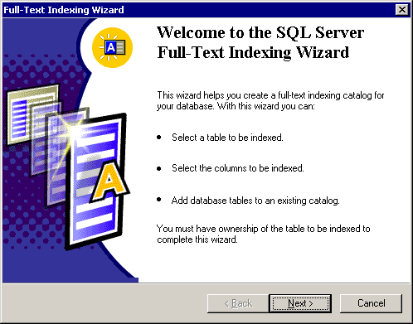
Figure 3

After you click Next, this dialog box is displayed:
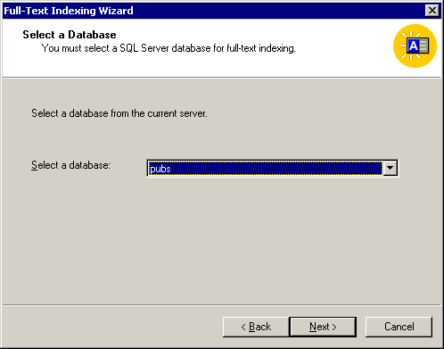
Figure 4

The database that you select is now enabled for full-text indexing.
Note Be careful. If full-text catalogs already exist for the database, then this procedure drops all the full-text catalogs for the database, and then re-creates any full-text indexing that is indicated in the system tables and marks the database as full-text enabled.

To determine if the database if already enabled for full-text, use this query:
SELECT DATABASEPROPERTY('%databasename%','IsFulltextEnabled')

After you click Next, this dialog box is displayed:
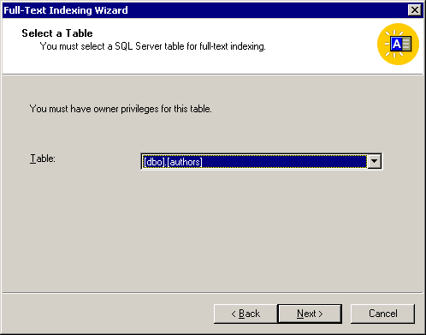
Figure 5

Now, the table is registered for full-text indexing. As stated in
the dialog box, you must have owner permissions to this table.
After you click Next, this dialog box is displayed:
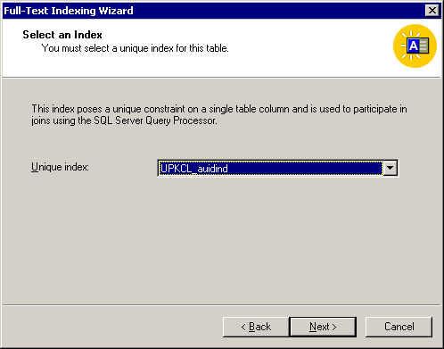
Figure 6
You must now specify the unique index on the table that you are going to use for full-text indexing. The unique index must be a single key column and non-nullable.
Note Always select the smallest unique index available for your full-text unique key. (A 4-byte, integer-based index is optimal.) This significantly reduces the resources the Microsoft Search service requires in the file system. If the primary key is large (over 100 bytes), consider choosing another unique index in the table (or create another unique index) as the full-text unique key. Otherwise, if the full-text unique key size reaches the maximum size permitted (450 bytes), the full-text population cannot proceed.
If you select a table that does not have a unique single column index, the wizard exits with the following dialog box:
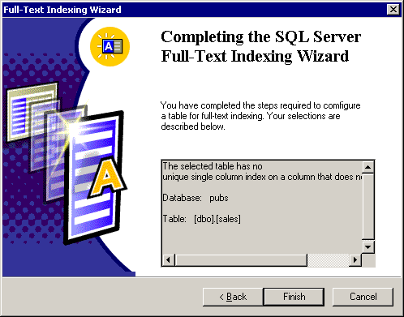
Figure 7

After you successfully select the unique index, this dialog box is displayed:
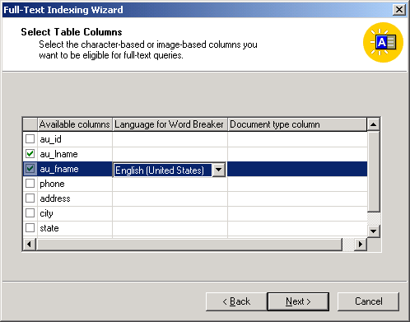
Figure 8

You can now select the columns that will support full-text indexing. The column, Language for Word Breaker, specifies the language of the data stored in the column that will be full-text indexed. You must select Neutral if there will be multiple languages in the column or if there will be an unsupported language. The default full-text language configuration option specifies the default. To change the default option, use the sp_configure stored procedure.
The Document type column specifies the column, in the same table, that will store the type of document that is being full-text indexed. This is only effective if the column that is being full-text enabled is an image type. With SQL Server 2000 you can full-text enable tables that store documents of different types. For example, a Microsoft Office document. For more information, read the "Localization" section of this white paper.

In the next dialog box, if any full-text catalogs exist, you can use them to store the full-text index, or you can create a new full-text catalog:
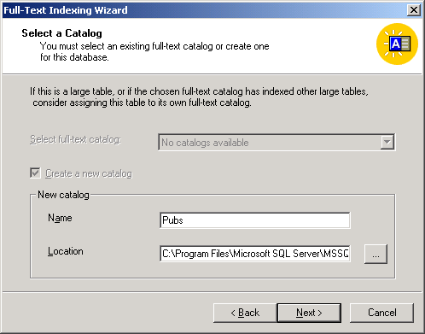
Figure 9

You can also specify the location in which the catalog is stored; otherwise, the default location is the Program Files\Microsoft SQL Server\MSSQL$Instance_Name\FTData folder.

Restrictions
The following restrictions apply to full-text catalogs:
- The catalogs must reside on a local hard disk that is associated with the
instance of SQL Server. Removable hard disks, floppy disks, and network drives are not supported.
- You can create a maximum of 256 full-text catalogs on each server.
- A full-text catalog cannot belong to multiple databases.
- You cannot back up and restore a full-text catalog by using the Transact-SQL BACKUP and RESTORE statements.

In the next dialog box, you can select or create a population schedule:
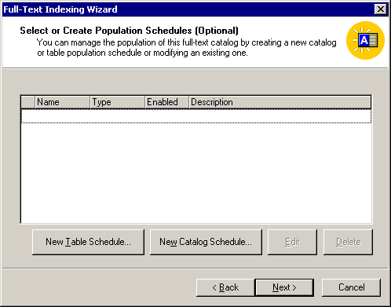
Figure 10

To create a population schedule for the table click New Table Schedule (see Figure 10).

In this dialog box, the Update Index option corresponds to a change tracking population:
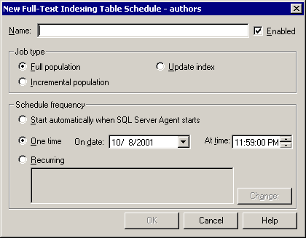
Figure 11

If you click New Catalog Schedule instead of New Table Schedule
in the dialog box shown in Figure 10, this dialog box is displayed:
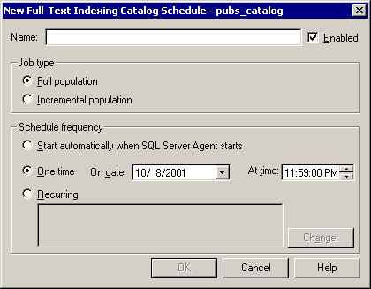
Figure 12
The only difference between the dialog box shown in Figure 12 and the dialog box for the New Table Schedule is the absence of the Update Index option. This is because with the catalog schedule, the whole catalog is updated, not just a specific full-text index on a table.
The final stage in this process is the following dialog box, which signifies success in enabling a table for full-text indexing:
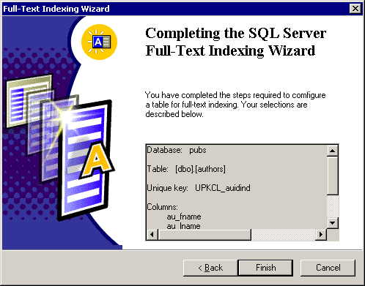
Figure 13

After you click Finish, SQL Server goes through the steps to enable
the table for full-text indexing. When the process completes, this dialog box is displayed:
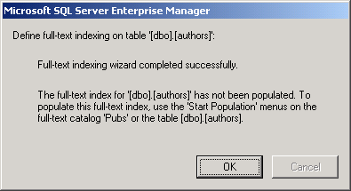
Figure 14

Note The preceding steps do not actually create the full-text index. You must invoke a full-population to create the index.

Alternatively, you can use Transact-SQL to enable a table for full-text indexing.
Follow these steps to use this method:
- Use this stored procedure to enable the database for full-text indexing:
sp_fulltext_database [@action =] 'action'
In the following example, the pubs database is enabled for full-text indexing:
use pubs
sp_fulltext_database 'enable'
go

You must use the sp_fulltext_catalog stored procedure to create the full-text catalog.
In the following example, a catalog named pubs is created:
use pubs
sp_fulltext_catalog 'pubs', 'create'
go

The preceding catalog is created in the default folder. If you do not want SQL Server to create the catalog in the default folder, you can specify the root folder by using this code:
sp_fulltext_catalog 'pubs', 'create', 'x:\Full-text Catalogs\'
go

You must register the table for full-text indexing by using the sp_fulltext_table stored procedure.
In the following example, the authors table is registered for full-text indexing:
use pubs
sp_fulltext_table 'authors', 'create', 'pubs', 'UPKCL_auidind'
go

You must specify the column for full-text indexing by using the following stored procedure:
sp_fulltext_column [ @tabname = ] 'qualified_table_name' ,
[ @colname = ] 'column_name' ,
[ @action = ] 'action'
[ , [ @language = ] 'language' ]
[ , [ @type_colname = ] 'type_column_name' ]

In the following example, the au_fname column is specified for full-text indexing:
use pubs
sp_fulltext_column 'authors', 'au_fname', 'add'
go

If you have to specify multiple columns, then you must run the preceding
stored procedure multiple times.
You must use the sp_fulltext_table stored procedure to register the full-text index on the table.
In the following example, the full-text index on the authors table is registered:
use pubs
sp_fulltext_table 'authors', 'activate'
go

The preceding code does not actually create the full-text index because the full-text index is created when the population of that full-text index starts.

How to Populate a Full-Text Index
After SQL Server creates a full-text index, you must run a full population on your index before you can run a query that uses the full-text index. Also, periodically you must update the full-text index by using change tracking or incremental population, as appropriate.
- To start a full or incremental population on a catalog basis, expand the Databases folder, and then click Full-Text Catalog. In the right-side pane, right-click the name of your catalog, and then click Start Full Population or Start Incremental Population, depending on the type of population you require.
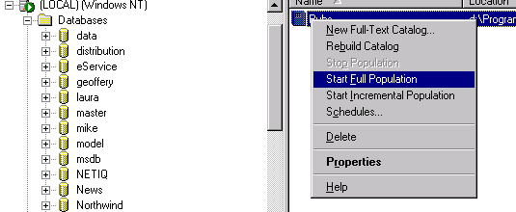Figure 15

- This dialog box is displayed, which indicates that the population has started:

Figure 16

Click OK.
The population will start. SQL Server does not notify you when the population completes.
- To determine if the population has completed, right-click the name of your catalog, and then click Properties. This dialog box is displayed:
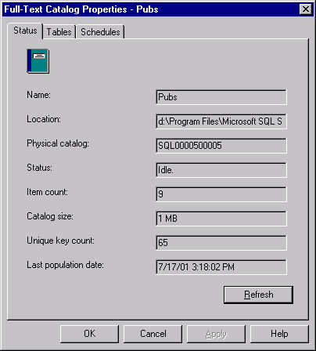
Figure 17
Continue to click the Refresh button until the Status text box contains the word "Idle."
Here is a quick review of the values displayed on the Status tab:
- Name: The name of your catalog.
- Location: The location of the index files. The files are actually in a subfolder that is named SQLXXXXXYYYYY.
XXXXX is the database ID. To obtain this value run the following query in the master database through the isqlw utility:
select dbid, name from sysdatabases order by name
YYYYY is the full-text catalog ID. The value begins with 5 and is incremented each time a new catalog is created in the same database.
By default, the folder is C:\Program Files\Microsoft SQL Server\MSSQL\FTDATA.
- Physical Catalog: The name of the catalog will be SQLXXXXXYYYYY where XXXXX is the database ID and YYYYY is the full-text catalog ID.
- Status: The status of the index (Idle, Full population in progress, Paused, Throttled, Recovering, Shutdown, Incremental population in progress, Building index, Disk is full. Paused, or Change tracking).
- Item Count: The number of tables and rows indexed. By default, with only one table being indexed, before you start your population the value is 1.
- Catalog Size: The size of your catalog in megabytes.
- Unique Key Count: The number of unique non-noise words in your index.
- Last population date: The time and date that the last population completed. Note that while a population is in progress, the time and date will reflect the time and date that SQL Server started the population.
You are now ready to query your catalog.
Alternatively, you can populate a full-text index by using Transact-SQL.
The following examples use Transact-SQL to populate a full-text index:
Full Population
To start a full population, on a catalog basis, use the following stored procedure:
sp_fulltext_catalog [ @ftcat = ] 'fulltext_catalog_name' ,
[ @action = ] 'action'
[ , [ @path = ] 'root_directory' ]

The following example starts a full population on the pubs full-text catalog:
use pubs
sp_fulltext_catalog 'pubs', 'start_full'

To start a full population on a table basis, use the following stored procedure:
sp_fulltext_table [ @tabname = ] 'qualified_table_name'
, [ @action = ] 'action'
[ , [ @ftcat = ] 'fulltext_catalog_name'
, [ @keyname = ] 'unique_index_name' ]

The following example starts a full population of the full-text index that is associated with the authors table:
use pubs
sp_fulltext_table 'authors', 'start_full'
go

Incremental Population
In the following example, Transact-SQL is used to start an incremental population on a full-text catalog:
use pubs
sp_fulltext_catalog 'pubs', 'start_incremental'

In the following example, an incremental population is started on the full-text index that is associated with the authors table:
use pubs
sp_fulltext_table 'authors', 'start_incremental'
go

Change Tracking Population
In the following example, a change tracking population is started on the full-text index that is associated with the authors table:
use pubs
sp_fulltext_table 'authors', 'start_change_tracking'
go

The following example shows how you can stop tracking all changes made to the full-text enabled authors table:
use pubs
sp_fulltext_table 'authors', 'stop_change_tracking'
go

As discussed in the "FULL-TEXT SEARCH ARCHITECTURE" section of this white paper, there are three ways for SQL Server to propagate changes when a full-text index is enabled for change tracking:
- Background
The following example shows how to do this by using Transact-SQL:
use pubs
sp_fulltext_table 'authors', 'start_background_updateindex'
go

- On demand
The following example shows how to do this by using Transact-SQL:
use pubs
sp_fulltext_table 'authors', 'update_index'
go

- Scheduled
As the name suggests, the job will run at a scheduled time.

To determine the population status of a full-text catalog, run either of the following stored procedures:
sp_help_fulltext_catalogs [ @fulltext_catalog_name = ] 'fulltext_catalog_name'

-or-

SELECT fulltextcatalogproperty('%CatalogName%', 'PopulateStatus')

An integer value is returned for the status, which you can interpret by using the following list:
0 = Idle
1 = Full population in progress
2 = Paused
3 = Throttled
4 = Recovering
5 = Shutdown
6 = Incremental population in progress
7 = Building index
8 = Disk is full. Paused
9 = Change tracking

How to Drop or Rebuild a Full-Text Catalog
To drop a full-text catalog, make sure that it does not contain indexes for one or more tables or the action will fail.
To remove a full-text catalog from Enterprise Manager, follow these steps:
- Expand a server group name, and then expand a server.
- Expand Databases, and then expand the database that contains
the full-text catalog to rebuild.
- Click Full-Text Catalogs, right-click the specific catalog
you want to remove, and then click Delete.
- Click Yes to remove the catalog.
To drop a full-text index on a table by using Transact-SQL, run this code:
Sp_fulltext_table @tabname = 'authors', @action = 'drop'

To drop a full-text catalog by using Transact-SQL, run this code:
Sp_fulltext_catalog @ftcatd = 'pubs', @action = 'drop'

When SQL Server rebuilds a catalog, it deletes the existing catalog from file system, re-creates the catalog, and then re-associates the full-text catalog with all the tables that have full-text indexing references. Rebuilding does not cause re-population of the full-text index. You must explicitly start a full population.
To rebuild a full-text catalog from Enterprise Manager, follow these steps:
- Expand a server group name, and then expand a server.
- Expand Databases, and then expand the database name that contains the full-text catalog to rebuild.
- Click Full-Text Catalogs, and then right-click the specific catalog to rebuild.
- Select Rebuild Catalog.
- Click Yes to rebuild the catalog.

To rebuild a full-text catalog by using Transact-SQL, run the following command:
Sp_fulltext_catalog @ftcatd = 'pubs', @action = 'rebuild'

Full-Text Search Query Predicates
SQL Server 2000 provides four different full-text Transact-SQL predicates that you can use to query a full-text index. More information about each predicate follows.

CONTAINS
CONTAINS is a predicate that you use to search for precise matches of single words and phrases, the proximity of words in a certain distance of one another, or weighted matches. CONTAINS can search for:
- A word or phrase.
- The prefix of a word or phrase.
- A word near another word.
- A word inflectionally generated from another (for example, the
word drive is the inflectional stem of drives, drove, driving, and driven).
- A word that has a higher designated weighting than another word.
In the following example, all product names that have at least one name that starts with the prefix "bush" in the productname column are returned:
use northwind
select productname
from products
where contains (productname, '"bush*"')
go

Note Each term in a CONTAINS statement is combined with a logical AND operation. For example, the following query returns only the rows that contain the words Blue AND Car:
Use northwind
Select productname
From products
Where contains (productname, ‘Blue Car’)

FREETEXT
FREETEXT is a predicate that you use to search for values that match the meaning and not the exact wording of the words in the search condition. With the FREETEXT predicate, the search condition is internally broken down into separate words. Each word is assigned a weight, and then the values that match are found.
Full-text queries that use FREETEXT are less precise than queries that use the CONTAINS predicate and are more likely to return results that meet the intent of the query.

In the following example, all the product categories that contain pasta and cheese in the product description are returned:
use northwind
select categoryname
from categories
where freetext (description, 'pasta cheese')
go

CONTAINSTABLE
The CONTAINSTABLE predicate returns a table of zero, one, or more rows based on a search for precise or fuzzy matches to single words and phrases, the proximity of words in a certain distance of one another, or weighted matches. CONTAINSTABLE can be referenced in the FROM clause of a SELECT statement as if it were a regular table name, and it uses the same search conditions as the CONTAINS predicate.
The table that is returned also has a column named Key, which has the full-text key values, and a column named Rank, which is a value from 0 through 1,000 for each row that indicates how well the row matched the selection criteria.
In the following example, the description and category name of the top 10 food categories where the Description column contains the words "sweet and savory" near either the word "sauces" or the word "candies" is returned:
SELECT FT_TBL.Description,
FT_TBL.CategoryName,
KEY_TBL.RANK
FROM Categories AS FT_TBL INNER JOIN
CONTAINSTABLE (Categories, Description,
'("sweet and savory" NEAR sauces) OR
("sweet and savory" NEAR candies), 10 ) AS KEY_TBL
ON FT_TBL.CategoryID = KEY_TBL.[KEY]

FREETEXTTABLE
The FREETEXTTABLE predicate returns a table of zero, one, or more rows based on a search for values that match the meaning and not the exact wording of the words in the search condition. FREETEXTTABLE can be referenced in the FROM clause of a SELECT statement as if it were a regular table name, and it uses the same search conditions as the FREETEXT predicate.
Similar to CONTAINSTABLE, the table that is returned by FREETEXTTABLE has two new columns named Key and Rank, which serve the same purpose as they did in the CONTAINSTABLE predicate.

In the following example, the category name and description of all the categories that relate to sweet, candy, bread, dry, and meat are returned:
USE Northwind
SELECT FT_TBL.CategoryName,
FT_TBL.Description,
KEY_TBL.RANK
FROM Categories AS FT_TBL INNER JOIN
FREETEXTTABLE(Categories, Description,
'sweetest candy bread and dry meat') AS KEY_TBL
ON FT_TBL.CategoryID = KEY_TBL.[KEY]
GO

Top_n_by_Rank
You use the Top_n_by_Rank parameter with the CONTAINSTABLE and FREETEXTTABLE predicates. It specifies that only the n highest ranked matches are returned, in descending order, and it applies only when an integer value, n, is specified.
This feature was available beginning with Microsoft SQL Server 7.0 Service Pack 2.
Specifying the Top_n_by_rank parameter in CONSTAINSTABLE and FREETEXTTABLE queries may improve query performance as long as the value of n is less than or equal to 2,000. If n is greater than 2,000 in a Top_n_by_rank query, performance degradation may occur.

Monitoring Full-text Search
You may have to monitor various stages of a full-text search, indexing or querying, to determine where bottlenecks may lie or to troubleshoot some performance-related issues. Also, you may have to perform periodic monitoring to determine if enough resources are available. Over time, most SQL Server application database deployments experience a significant growth in both the number of users and the amount of content that is accessed.

System Monitor Counters
You can use Microsoft Windows 2000 System Monitor to monitor full-text indexing and full-text search status and performance. There are performance objects that are installed with the Microsoft Search service. These objects are:
- Microsoft Gatherer
- Microsoft Gatherer Projects
- Microsoft Search
- Microsoft Search Catalogs
- Microsoft Search Indexer Catalogs
There are also some useful objects that relate to the system as a whole and also to SQL Server. These objects are:
- Logical Disk
- Memory
- Paging File
- Physical Disk
- Process
- Processor
- Server
- Thread
- All performance counters installed by SQL Server.

Full-Text Indexing or Population-Related Counters
Use the following counters with the Microsoft Gatherer and Microsoft Gatherer Projects objects to monitor full-text index population:

- Microsoft Gatherer: Documents Delayed Retry
The number of documents that will be retried after a time-out occurs.
- Microsoft Gatherer: Documents Filtered
The number of documents (rows) that have been filtered and the number that have been indexed. Corresponds to the total number of documents (rows) filtered in the system since startup.
- Microsoft Gatherer: Filter Process Created
The total number of times a filter process was created or restarted. Having too many filter processes created indicates that filtering is having trouble with the data in the documents.
- Microsoft Gatherer: Performance Level
The performance level varies from 1 to 5 as set by system stored procedure sp_fulltext_service resource_usage (1=background, 3=default, 5=dedicated). Indicates the amount of system resources that the Gatherer service is permitted to use.
- Microsoft Gatherer: Reason to back off
Shows a code that describes why the gathering service stopped the population.
0 - Up and running
1 - High I/O rate
4 - Back off on user activity (by default this is disabled in server install)
5 - Battery low (currently, if running on battery, not on AC power)
6 - Memory low (less than 5 MB left in paging file)
- Microsoft Gatherer: System IO traffic rate
Shows the I/O rate that is used to determine whether to reduce crawl processing. See physical disk counters for more detailed I/O diagnostic information. System I/O (disk) traffic rate in KBs detected by back off logic.
- Microsoft Gatherer Projects: Crawl in Progress Flag
Contains 0 or 1 and indicates whether a population (or crawl) is running:
0 = Population is running
1 = Population is not running for a specific instance of a full-text catalog.
- Microsoft Gatherer Projects: Current Crawl is Incremental
Contains 0 or 1 and indicates whether the population is incremental:
0 = Incremental crawl.
1 = Full crawl for a specific instance of a full-text catalog.

- Microsoft Gatherer Projects: Gatherer Paused Flag
Contains 0 or 1 and indicates a paused population:
0 = Not paused.
1 = Paused for a specific instance of a full-text catalog. If a full-text catalog is paused, stop and then re-start the Microsoft Search service.
- Microsoft Gatherer Projects: URLs in History
Shows the total number of URLs (rows) known to full-text indexing for a specific instance of a full-text catalog.
- Microsoft Gatherer Projects: Waiting Documents
Shows the number of documents (rows) waiting to be populated. This number increases at the start of a crawl as new rows are identified, and then decreases as the population progresses for a specific instance of a full-text catalog.
- Microsoft Search Indexer Catalogs: Merge Progress
Shows the progress of an index merge for a specific instance of a full-text catalog. The percentage of merge complete for the current merge.

Full-Text Search Query-Related Counters
The following counters for Microsoft Search catalogs contain information about full-text indexing queries. Use them to monitor queries executed against the full-text index. The Microsoft Search performance object contains the total of the values found in four separate catalogs in the Microsoft Search catalogs object.
- Microsoft Search: Active Threads
The total number of threads currently servicing queries.
- Microsoft Search: Threads
The total number of threads that are available for servicing queries.
- Microsoft Search Catalogs: Queries
Shows the total number of queries performed. Cumulative number of queries posted to the full-text catalog for a specific instance of a full-text catalog.
- Microsoft Search Catalogs: Successful Queries
Shows the number of successful queries. The number of queries that produce successful searches for a specific instance of a full-text catalog.

- Microsoft Search Catalogs: Results
Shows the number of rows returned, after trimming, to the scope of the query. The cumulative number of results returned to clients for a specific instance of a full-text catalog.
- Microsoft Search Catalogs: Failed Queries
Shows the number of failed queries (for example, those containing noise words). The number of queries that have failed for a specific instance of a full-text catalog.

Some other factors that can affect the performance of full-text are:
Resource Usage
Full-text indexing is a CPU and memory intensive operation. It is typical to see CPU usage close to 100 percent, especially during times of full population. There are query and index performance settings that you can set by using the sp_fulltext_service stored procedure. The syntax to set the resource usage value is:
Exec sp_fulltext_service 'resource_usage', <value>

The value ranges from 1 to 5 where 1 makes the Microsoft Search process purely background and 5 lets the Microsoft Search process use whatever resources it wants on the server. The default value for this setting is 3.
This setting also controls the number of concurrent connections that are permitted to the Microsoft Search service. The following table shows the setting and the number of concurrent connections permitted:
Resource_usage | Concurrent connections
1 | 128
2 | 512
3 | 1024 (default)
4 | 2048
5 | 4096

The default value of 3 is enough for tables that have fewer than 1 million rows. For tables with more than 1 million rows, there is a tradeoff between changing this setting and the affinity of the CPUs that are used by the Microsoft Search process, assuming that it is a multi-processor server. Here are few guidelines to help you make the choice:

- If the server has some time throughout the day where it experiences low usage, then Microsoft recommends that you reduce the "resource_usage" setting rather than changing the affinity of the MSSearch process. This permits full-text search to maximize the use of resources when the computer is otherwise idle.
- If the server is always under extreme load then Microsoft
recommends that you affinitize the Microsoft Search process so that it has an opportunity to keep up. This makes sure that one single process does not monopolize all the CPUs on the server and permits the full-text search to throttle regardless of the usage of the rest of the computer. To set the affinity for Microsoft Search, follow these steps:
- Open Task Manager, and then click Processes.
- Right-click Mssearch.exe.
- Click Set Affinity, and then click to select the processors.
Note: The Set Affinity command in Task Manager is available only on a multi-processor computer.
At this time, together with Microsoft Search, Microsoft also recommends that you change the affinity mask configuration option of SQL Server so that SQL Server will use other processors. This prevents the Microsoft Search use of the CPU from affecting SQL Server performance. For details about how to change this option for SQL Server, see the "affinity mask Option" topic in SQL Server 2000 Books Online.

MaxPropStoreCachedSize
For SQL Server 2000 tables that have a large number of unique words, generally associated with a large number of rows (10 million or more), you can improve the full-text search performance by modifying or adding the MaxPropStoreCachedSize registry key value:
HKEY_LOCAL_MACHINE\SOFTWARE\Microsoft\Search\1.0\Indexer\MaxPropStoreCachedSize REG_DWORD 256 (in MB, decimal)

If the sum total of the file sizes of the full-text catalog property store files (*.ps1 and *.ps2) located in the FTDATA\<FT_Catalog_name>\Build\Indexer\NlFiles folder is greater than 256 MB, (the default value for MaxPropStoreCachedSize), you must set this registry value to a value that is 5 percent larger than the sum of the *.ps1 and .ps2 file sizes on this server. Then, you must stop and restart the Microsoft Search service. Note that the increase must cover the expected near-term growth and not set to the maximum value first. Expect a 25 percent to 35 percent increase in the performance of your
CONTAINS, CONTAINSTABLE, FREETEXT or FREETEXTTABLE queries that have large full-text enabled SQL Server tables. You can also set this registry value at the full-text catalog level by adding the following registry key:
HKEY_LOCAL_MACHINE\SOFTWARE\Microsoft\Search\1.0\Indexer\SQLServer\<FT_Catalog_Name>\MaxPropStoreCachedSize REG_DWORD

You can also improve the performance of full-text query by warming up the property store. To warm up the property store, run a set of typical queries against the catalog to populate the cache used by Microsoft Search. This way, common queries will run faster the first time and then every time because they have already been cached partially by Microsoft Search.
Note Do not use a value that is greater than the 2 GB process address space (the sum of all property store files for all catalogs must be smaller than 2 GB and also leave room for general memory usage).

Basic Full-Text Indexing Troubleshooting
If an error occurs during the creation or population of a full-text index, see the following logs:
Windows 2000 Event Logs
The Windows 2000 Application Event Logs are a valuable resource for troubleshooting full-text indexing issues. They can be filtered for events with a source of Microsoft Search or MssCi.
Gatherer Logs
Gatherer logs are files generated during the population of a full-text index. They have a .gthr file name extension, and are stored in the following folder:
FTDATA\SQLServer$<instance_name>\GatherLogs
The .gthr file name format is SQL0000500006.12.gthr, where 5 is the database_id , 6 is the full-text_id, and 12 is the population number.
If a row cannot be full-text indexed, an error message is written to the gatherer log. The error message includes the file name and the error number. To decode the error message, you must use a special utility. The utility is a Microsoft Visual Basic® Script, Gthrlog.vbs, which is located in the following folder:
Program Files\Common Files\System\MSSearch\Bin
You can run this script from the command line in the following manner
cscript gthrlog.vbs <file name>

where <file name> is the fully qualified path to the gatherer log. The results from this utility are displayed at the command prompt.
You can also use SQL Profiler to monitor all the commands that are being run by SQL Server to satisfy full-text operations. In the Profiler Trace output, look for the execution of the sp_fulltext_getdata stored procedure. The sp_fulltext_getdata stored procedure is invoked by the Full-Text Protocol Handler after a connection is made to SQL Server. Therefore, this is the information that corresponds to retrieval of data from the SQL Server table. You can use this tool to find slow queries or to see what else is occurring in SQL Server at the same time as a full-text operation, which might be interfering with or affecting the operation.
A SQL Server 2000 trace definition file is included with this white paper, which captures the necessary events to show the preceding information.

How to Recover from a catastrophic Failure
If a catastrophic failure occurs, you must always be prepared to restore all your databases from backups. You can back up and restore SQL Server databases by using the Transact-SQL commands BACKUP and RESTORE. However, you cannot use those commands to back up and restore full-text catalogs. So, how do you back up and restore a full-text catalog?
Full-text catalogs are stored as files in the file system, and they are managed by the Microsoft Search service. To back up and restore these catalogs, there are a number of considerations that you must take into account. These considerations, and the steps involved in backing up and restoring these full-text catalogs are all discussed in the following Microsoft Knowledge Base article:
Q240867 - INF: How to Move, Copy, and Back Up SQL 7.0 Full-Text Catalog Folders and Files
http://support.microsoft.com/support/misc/kblookup.asp?id=Q240867

For More Information
For more information about SQL Server 2000 full-text search, see the following articles in the Microsoft Knowledge Base:
- Q270671 - PRB: Full Text Search Menus Are Not Enabled for Local Windows NT Accounts
http://support.microsoft.com/support/misc/kblookup.asp?id=Q270671

- Q286787 - FIX: Incorrect Results From Full-Text Search on Several Columns
http://support.microsoft.com/support/misc/kblookup.asp?id=Q286787

- Q246800 - INF: Correctly Parsing Quotation Marks in Full Text Search Queries
http://support.microsoft.com/support/misc/kblookup.asp?id=Q246800

- Q295051 - FIX: Changing SQL Server Account to Non-Admin for Full-Text Search Makes Existing Catalogs Unusable
http://support.microsoft.com/support/misc/kblookup.asp?id=Q295051

- Q297209 - FIX: Deletes, Updates and Rank Based Selects May Cause Deadlock of MSSEARCH
http://support.microsoft.com/support/misc/kblookup.asp?id=Q297209

For more information about Microsoft SQL Server, see SQL Server Books Online.

